***Curriculum Vitae***

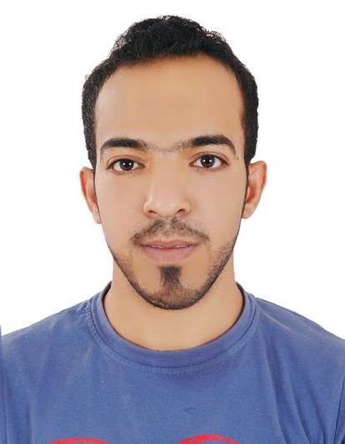

***Yasser Fadhel Abbas Ali Adwain***

***House:1681, Block:1214, Road:1425, Hamad Town***

***Mobile phone: (00973) 38800343***

***(00973) 33974731***

***E-mail:*** *yasseredwin1993@gmail.com*

***PERSONAL DATA***

* **Nationality:** Bahraini
* **Date of Birth:** 19-05-1993
* **Place of Birth:** Manama
* **CPR Number:** 930508386
* **Material Status:** Married

***ACADIMIC QUALIFICATIONS***

2013 ***Shaikh Isa bin Ali Secondary school***

***Experience***

2015 - present ***Worked as a sales associate at HomeCentre, Al-Rashid Group for Retails***

***Achievements***

July 2016 ***Selected as employee of the month***

***Qualifications***

* Driving License and Private Car.

***ADDITIONAL SKILLS***

* **Interpersonal :**
* Quick learner.
* Leadership skills.
* Hard worker.
* Good Communication skills.
* **Languages :**
  + Arabic fluently speaking, reading and writing.
  + Good English speaking, reading and writing.

* **IT literacy skills:**
  + Knowledge in Microsoft Windows, MS Office applications (Word, Power Point, Excel, and Internet Explorer).

***INTERESTS AND HOBBIES***

* Swimming.
* Riding horses.
* Surfing the Internet.
* Exchanging ideas and chatting with people from different ages with different nationalities.

**For further recommendations, contact Mr. Jayasimha Reddy, HomeCentre Store Manager.**

**Phone number: 00973-33312309**

**Email:** [**jayasimha.reddy@arg.com.bh**](mailto:jayasimha.reddy@arg.com.bh)

**LAST UPDATE: Dec 2017**